**Semester: V (2023-24) Subject:** Communication Protocols

**Name: Class:**

**Roll No: Batch:**

**Experiment No: 03**

**Name of the Experiment**: Study of GNS3 simulator and basic network configurations

**Performed on:**

**Submitted on:**



**Aim:** To study GNS3 simulator and basic network configurations.

**Pre requisite:** Basic knowledge of network components and its working principle.

**Objectives:**

* To study GNS3 network simulator
* To simulate a basic network using GNS3

**Components and equipment required/studied:**

* Computer with GNS3 software installed on the system (preferably Windows).

**Theory:**

The Graphical Network Simulator-3 is an open source, free network software emulator that is used by over one million network engineers, students, and architects all over the world to simulate, configure, test, and troubleshoot virtual and real networks.

* When building a new enterprise network, it can be useful to simulate the network before going live. A simulation allows for better testing and troubleshooting, as well as creating different models to find the one that is most effective for the desired need.
* GNS3 that allows simulation of complex networks. You may be familiar with VMware or Virtual PC that are used to emulate various operating systems in a virtual environment.
* During this process, you need to create network devices and host them on the server process. In principle, the server component can be executed as a local virtual machine (VM) and as a remote VM
* The software allows users to simulate a wide range of networks, from running a small topology that consists of only a few devices on your laptop, to those that consist of many devices hosted on multiple servers or in the cloud.

GNS3 supports many devices from various network vendors including Cisco virtual switches, Cumulus Linux switches, Cisco ASAs, Brocade vRouters, HPE VSRs, Docker instances, multiple Linux appliances and many others.

**Procedure:**

1. Open GNS3 and enter name of new project
2. On left-hand side of screen browse to Router option and select a router IOS image (preferably c1700). Drag two routers on the screen. If no routers are available follow the given steps:
   1. Download an IOS image from internet
   2. In GNS3 menu bar select **Edit—Preferences**
   3. In the preferences window under **Dynamips** select **IOS routers**
   4. Click on the **New** button and browse to the location of newly downloaded router image (c1700)
   5. A new router image has been added to the **Router option**
3. Browse to End devices to select VPCS. These will be the node/workstation connected to routers
4. To make connections, click on Add a link option on left-hand side and execute the following steps
   1. Select PC1, and in drop down menu choose Ethernet0/0.
   2. Drag your mouse to and click R1, choose Ethernet0 from drop down menu.
   3. Repeat steps a) and b) for PC2
   4. To connect the routers R1 & R2, click on R1 and choose FastEthernet0/0, drag and select FastEthernet0/0 option in R2.
5. Assigning IP address to PC

* Open console and type the following command **ip <ip address> <gateway> <mask>**

1. Assigning ip address to Router

* Execute the following commands in R1 window
  + config t
  + int f0 (for FastEthernet port) || int e0 (for Ethernet port)
  + ip add <ip address> <255.255.255.0>
  + no shut

1. 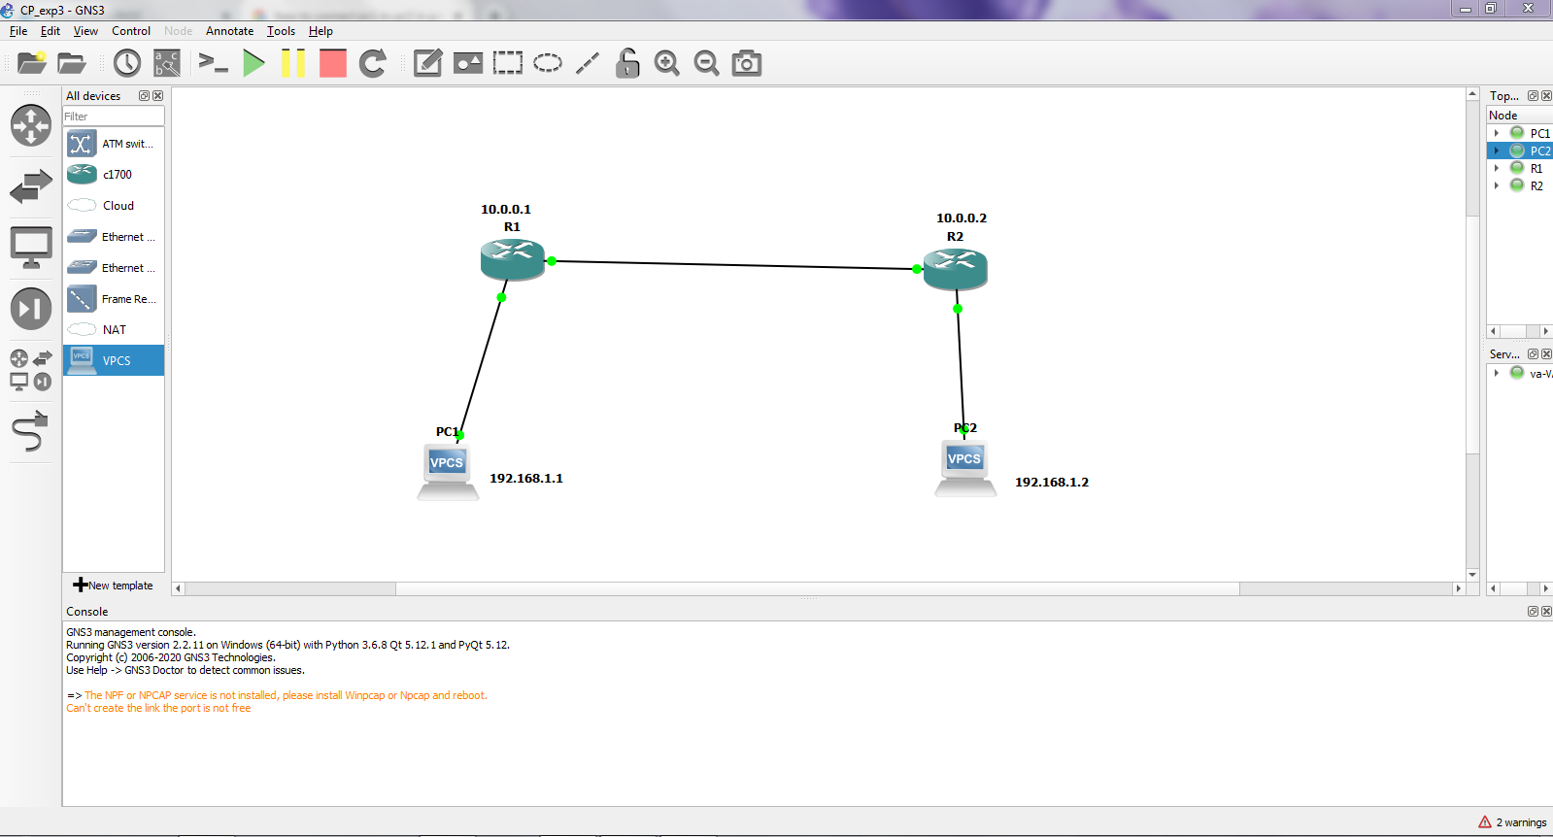Similar way, we need to configure all the devices. Once it is done, we can check whether the network is correctly configured or not by using ping command at different interfaces or by pinging from one PC to other PC.

**Figure SEQ Figure \* ARABIC 1 Basic network configuration**

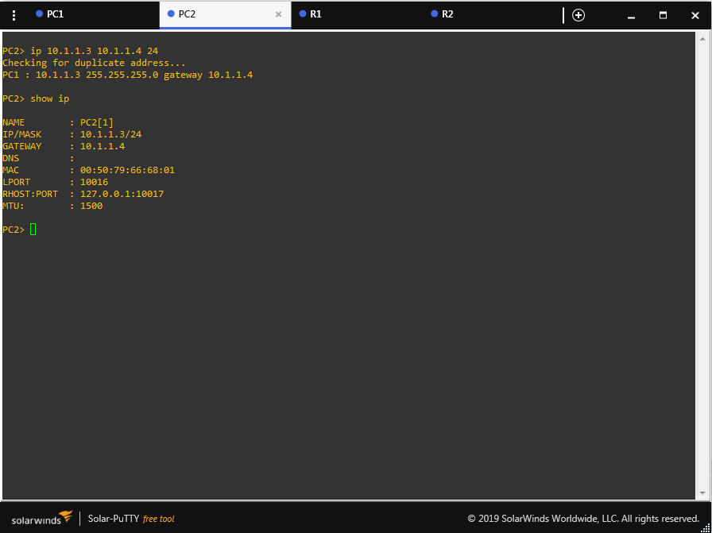

**Figure 2 Configuration of PC**

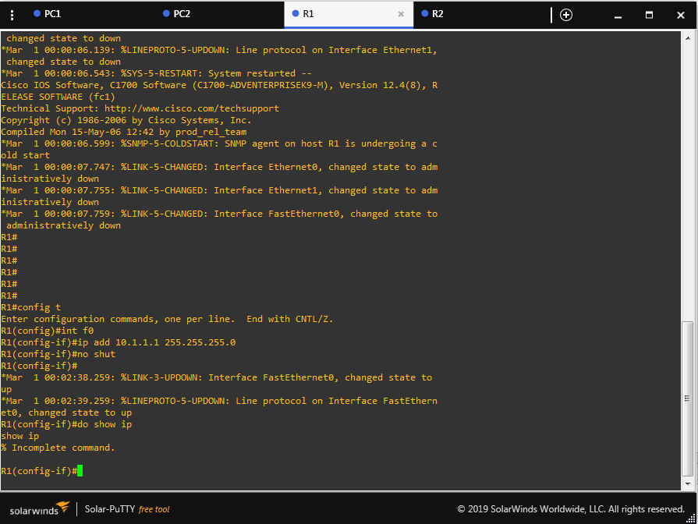

**Figure 3 Configuration of Router**

**Conclusion:**

**Post Lab Questions:**

1. What is Gateway? Why does a PC need to be assigned a gateway?
2. What is Fast Ethernet?
3. Write advantages of GNS3
4. Explain the command: no shut
5. What is mean by IOS?